**GitHub-**

Create the central repository on GitHub.

**Git-**

Install Git on your local machine by “git init” command to create the local repository.

Or

Git clone or clone your repository from GitHub.

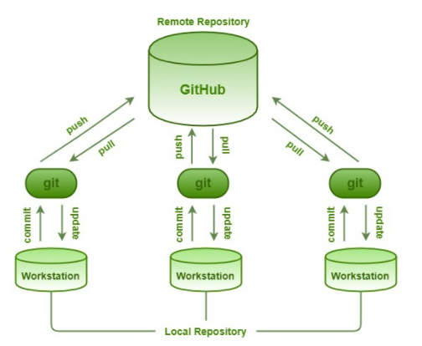

Note-

1. Repository name should be unique.
2. Select type as private or public.
3. Click on create repositories

**Create repositories-**

**Step- 1- Clone the repository into your local machine.**  
Click on the **“clone”** button on the right corner of the dashboard. A prompt with the URL link would appear. the URL link would look like <https://USERNAME@bitbucket.org/USERNAME/REPOSITORY_NAME.git>

**Step-2- Copy and paste the link in the terminal after typing git clone**

Try to create the local repositories for that you need to install Git on machine

Go to system folder->where you create the repositories.

Right click->Git base here then it it will open the command prompt.

git clone (REPOSITORY URL)

git clone https://USERNAME@bitbucket.org/USERNAME/REPOSITORY_NAME.git

Note-Clone means, it will retrieve all the contents from that directory to your local machine where you are working, without affecting the Bitbucket repository.

**Sync repositories-**

How to copy the url(Go to GitHub site, click on clone or download button, copy that URL.

**How to copy the files from remote repository to local repository by using below command**

git pull origin master

now the files has been added to your local repositories.

Then next time onwards.

If you want to get the changes from central repository then use

git push origin master-

It will copy changes from local repository to remote repository.

so automatically it will retrieve the data from central repository. So you will get the latest code then after make the changes in your local repository then use command git push to commit the changes to remote repository.

**Making the changes-**

Git status- this will display list of files which are added to local repository

Git add- add the files to your index.

🡪git add filename is suppose login.java

Git commit- commit the changes to repository

🡪git commit –m “login method change” and press enter. Used to commit the changes into local repository

🡪git log- to check the history

**Parallel development-**

**How to create the new branch**

git branch rambranch

--this will contain all data of master branch because its originated from master branch.

If you want to move from one branch to another branch that is called as checking out.

git branch checkout master

Now this will points to your branch not master.

Starts write the code then

git add sample

git commit //commited changes to local repository

git push //push the changes to remote repository

press top arrow key on keyword to view previous existing command

git commit –m “added the one field”

git push origin master //changes to

🡪points to master branch then type

git merge rambranch (branch name)

* git push- copy the changes from local to remote repository
* git pull- copy or fetch the changes from remote to local repository

to view all branch command

git branch –all - it will display the list

**How to raise the pull request for code review on bitbucket**

Step-1 – Go to url <http://bitbucket.srv.wipro.com/project/> Pro-01 (this is project name)

Step-2 -Select repositories Pro-01-Java

Step 3- select source branch name

Step 4- create the pull request

Source- your branch

Destination- Master

Click on continue button

Mention your reviewer name as manager name-> manager code review-Comment-Mail trigger-> view pull request button on mail-> Navigate to that-> see the comment in details and make the changes.

Note- In our project Bit bucket with GIT